|  |  |
| --- | --- |
| **WC Logo.emf** | **Staff Report to the Weber County Commission**  *Weber County Planning Division* |
|  | |

****Synopsis****

****Application Information****

**Application Request:** Public hearing to consider and take action on a request to vacate a public utility easements located along the eastern boundary of lot 1, Weber Industrial Park Plat A, Lot 8, Amended.

**Agenda Date: Tuesday, April 6, 2021**

**Applicant: Four Star Investments LLC**

**File Number:** EV2021-02

****Property Information****

**Approximate Address:** 2458 N Rulon White Blvd, Ogden, UT, 84404

**Project Area:** Variable

**Zoning:** R-2

**Existing Land Use:** Residential

**Proposed Land Use:** Residential

**Parcel IDs:** 19-228-0004

**Township, Range, Section:** T7N, R2W, Section 36, NE

****Adjacent Land Use****

**North:** Commercial **South:** Commercial

**East:** Commercial **West:** Rulon White Blvd

****Staff Information****

**Report Presenter: Tammy Aydelotte**

[taydelotte@webercountyutah.gov](mailto:taydelotte@webercountyutah.gov)

**801-399-8794**

**Report Reviewer:** SB

Background and Summary

The applicant has submitted a request to vacate the 10-foot wide public utility easements along the east (rear) lot line for lot 1 of the Weber Industrial Park Plat A, Lot 8, Amended plat. The purpose of the vacation request is to allow the owner to combine parcels into a one-lot subdivision, in order to expand the existing structure. See **Exhibit A** for requested easements to be vacated by the applicants.

Weber County Engineering Department Analysis

The Weber County Engineering Department has submitted a review on this request as follows:

*I have had a chance to review the proposed easement vacation request and have the following comments:*

1. *The public utility easement along the rear of lot 1 can be vacated.*
2. *The public utility and drainage easement along the east lot lines of lot 11 can be vacated.*

Analysis

*General Plan*: The vacation of unutilized easements is not anticipated to have a negative effect on the Southeast Planning Area Comprehensive Land Use Master Plan (1971).

*Public Notice*: Public noticing and the noticing of potentially affected entities has been provided as outlined in state code Section 17-27a-208. No responses from the surrounding public or other possibly affected entities have been received at the time of the drafting of this report (02/05/2021).

Commission Considerations

The applicant has proposed to vacate the public utility easements by ordinance. Under the state code, Section 17-27a-609.5, the legislative body may adopt an ordinance granting a petition to vacate some or all of a public street, right-of-way, or easement if the legislative body finds that:

(a) good cause exists for the vacation; and

(b) neither the public interest nor any person will be materially injured by the vacation.

Staff Recommendation

Staff recommends the vacation of the public utility easement that has been recommended by the Weber County Engineering Department and the enclosed Vacation Ordinance (see **Exhibit B**). This recommendation for approval is based on the following findings:

The Weber County Board of Commissioners may adopt an ordinance granting a petition to vacate some or all of a public street, right-of-way, or easement if the legislative body finds that:

(a) good cause exists for the vacation; and

(b) neither the public interest nor any person will be materially injured by the vacation.

1. Vacating the identified easements will not have a negative effect on the Western Weber Area Comprehensive Land Use Master Plan.
2. The public interest or any person will not be materially injured by the proposed vacations.
3. The vacations will not be detrimental to the public health, safety, or welfare.
4. The vacations will not deteriorate the environment of the general area so as to negatively impact surrounding properties and uses.

Exhibits

1. Easement to be vacated
2. Draft Vacation Ordinance

Area Map

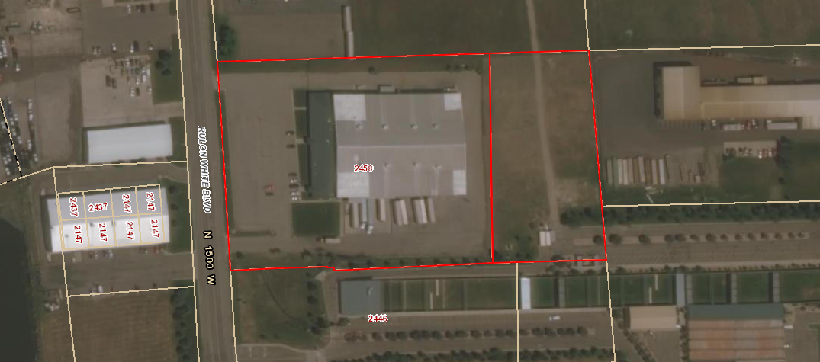

Exhibit A – Easement to be Vacated

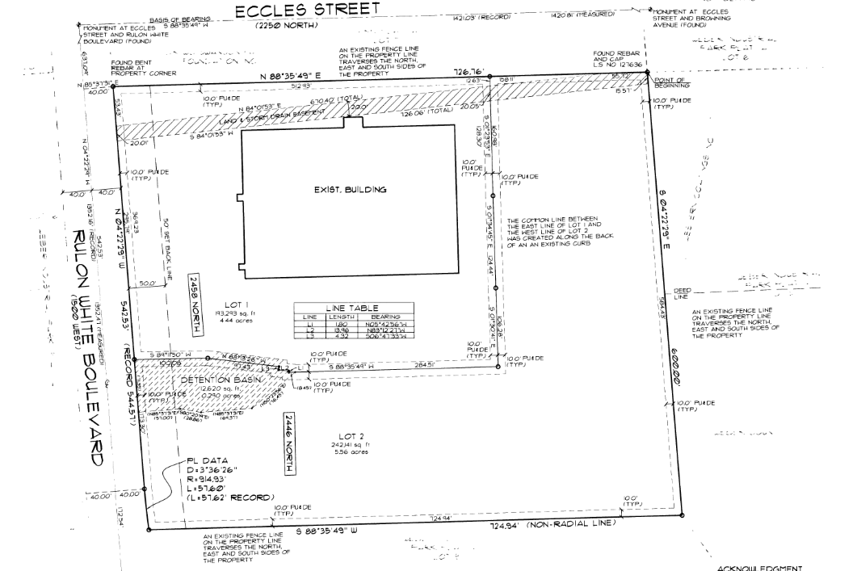

Easement to be vacated

Exhibit B – Vacation Ordinance

**Ordinance**

**An ordinance of Weber County vacating a 20-foot wide public utility easement, located approximately 512.93’ from the front property line, which runs north-south and straddles the east boundary between Lot 1 of the Weber Industrial Park Plat A, Lot 8, Amended, and the parcel directly east. This ordinance does not vacate the 20-foot easement that straddles the southern boundary of Lot 1 and the northern boundary of Lot 2 Weber Industrial Park Plat A, Lot 8, Amended.**

**Whereas,** Four-Star Investments, have filed a petition to vacate 20-foot wide public utility easement, located approximately 512.93’ from the front property line, which runs north-south and straddles the east boundary between Lot 1 of the Weber Industrial Park Plat A, Lot 8, Amended, and the parcel directly east;

**Whereas,** after providing proper public notice, a public hearing was held on April 6, 2021, regarding the proposed easement vacation;

**Whereas,** The Weber County Engineering Department has been notified and has provided written approval of the vacation of the public utility easement;

**Whereas,** the vacation of the public utility easement will not substantially affect the Western Weber County General Plan or the health, safety, and welfare of the general public, and the Weber County Board of Commissioners finds that good cause exists for the vacation and that neither the public interest nor any person will be materially injured by the vacation;

**Now, Therefore,** the Weber County Board of Commissioners vacates the following:

**The 20-foot wide public utility easement, located approximately 512.93’ from the front property line, which runs north-south and straddles the east boundary between Lot 1 of the Weber Industrial Park Plat A, Lot 8, Amended, and the parcel directly east, as highlighted with a dashed line on the 2021 Recorder’s plat (19-228) below, is hereby vacated.**

Passed, adopted, and ordered published this day of , 2021, by the Weber County Board of Commissioners.

_____________________________________

James Harvey, Chair

Commissioner Harvey Voting

Commissioner Froerer Voting

Commissioner Jenkins Voting

ATTEST:

Ricky Hatch, CPA Weber County Clerk

